ESNsurvey XVI is out!
The Erasmus Student Network (ESN) has recently launched the latest edition of the ESNsurvey, the largest student-led survey focusing on student exchanges and the internationalisation of higher education from the student perspective.
You can access the survey here: https://esnsurvey.org/
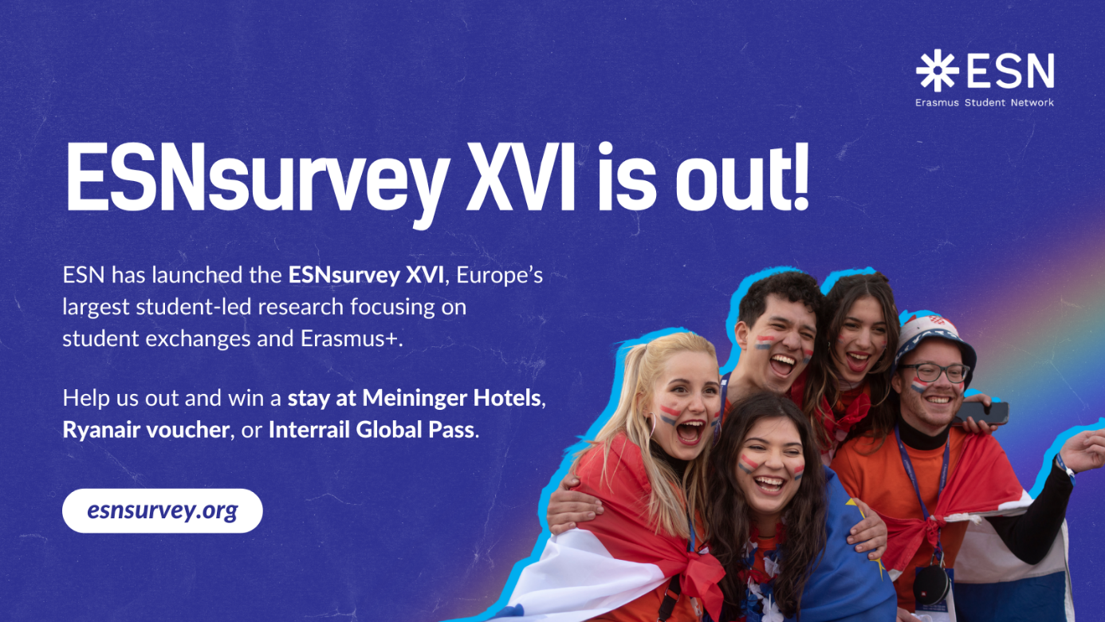
The survey is open to:
- students who have taken part in an exchange during the last two years (or even before 2023),
- all international students pursuing their degrees abroad (including at our University),
- and students who have not participated in any exchange experience.
By completing the survey, you’ll have the chance to win a stay at Meininger Hotels, a Ryanair voucher, or an Interrail Global Pass!
Through this initiative, ESN is gathering insights on how to improve the Erasmus+ programme and other mobility opportunities — and your input is essential. The survey takes approximately 20 minutes, and all responses are completely anonymous.
If you have any questions, feel free to contact the ESN Survey Team at surveyteam@esn.org.
___________________________________

